TCSS 446 QUIZ 1
Name: Linda Miao | Server: 30270184STFPC29
Execution time table:
Run | Scan type | N(rows) | Completion Time
1 | Table Scan | 1000 | 13:40:12
2 | Table Scan | 2000 | 14:52:35
3 | Clustered Index Scan | 2000 | 14:52:35
4 | Non-Clustered Index Scan | 2000 | 14:52:35

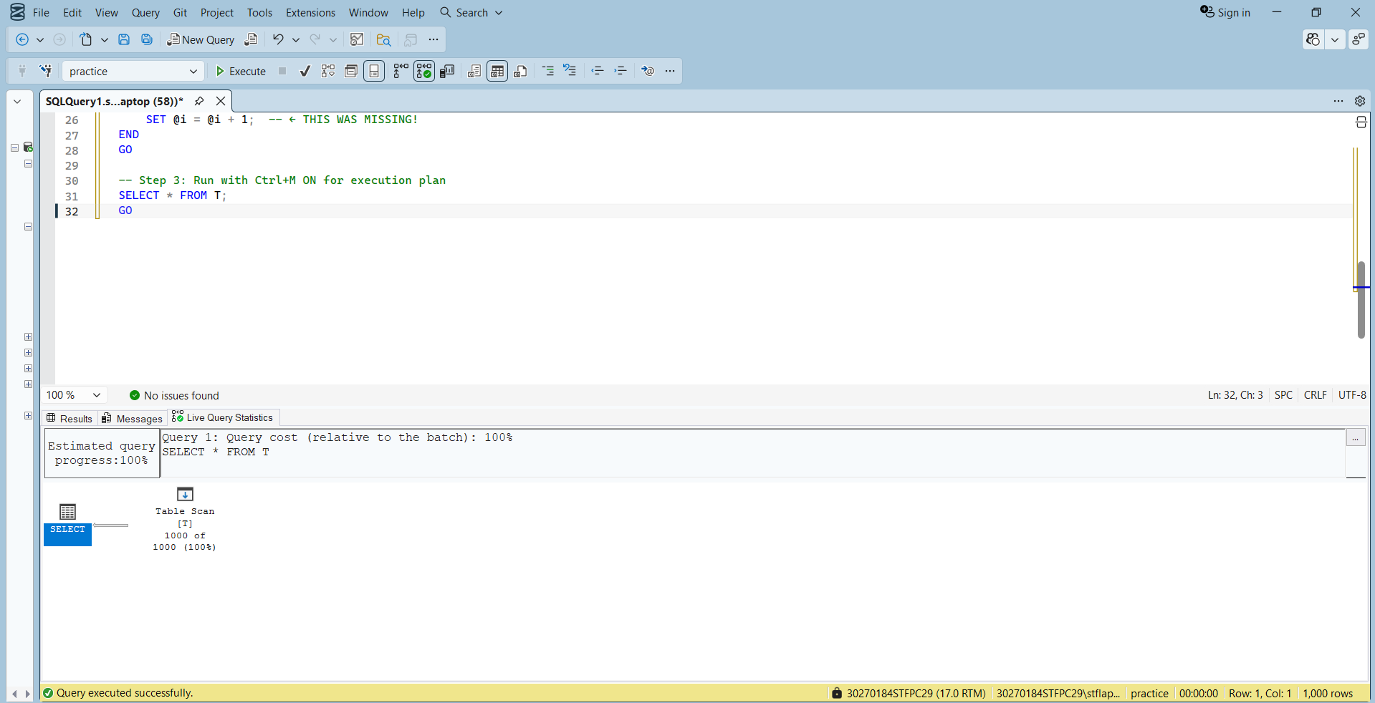
Step 3 - Table Scan (n=1,000): No index exists. SQL Server scans every row in the table. Cost: 100%. Time: 13:40:12

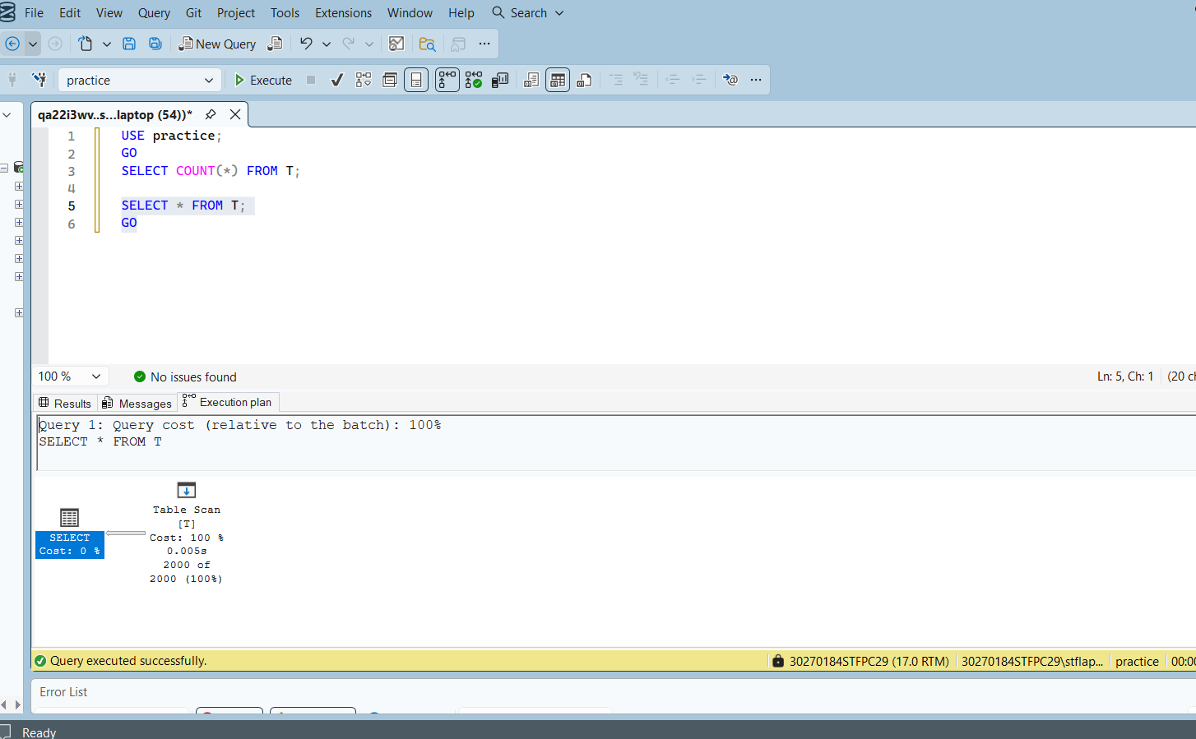
Step 3 - Table Scan (n=2,000): No index exists. SQL Server still scans every row. Time increases as rows increase.

Step 4 - Clustered Index Scan (n=2,000): Primary key added on id column. SQL Server uses clustered index to read rows in sorted order.

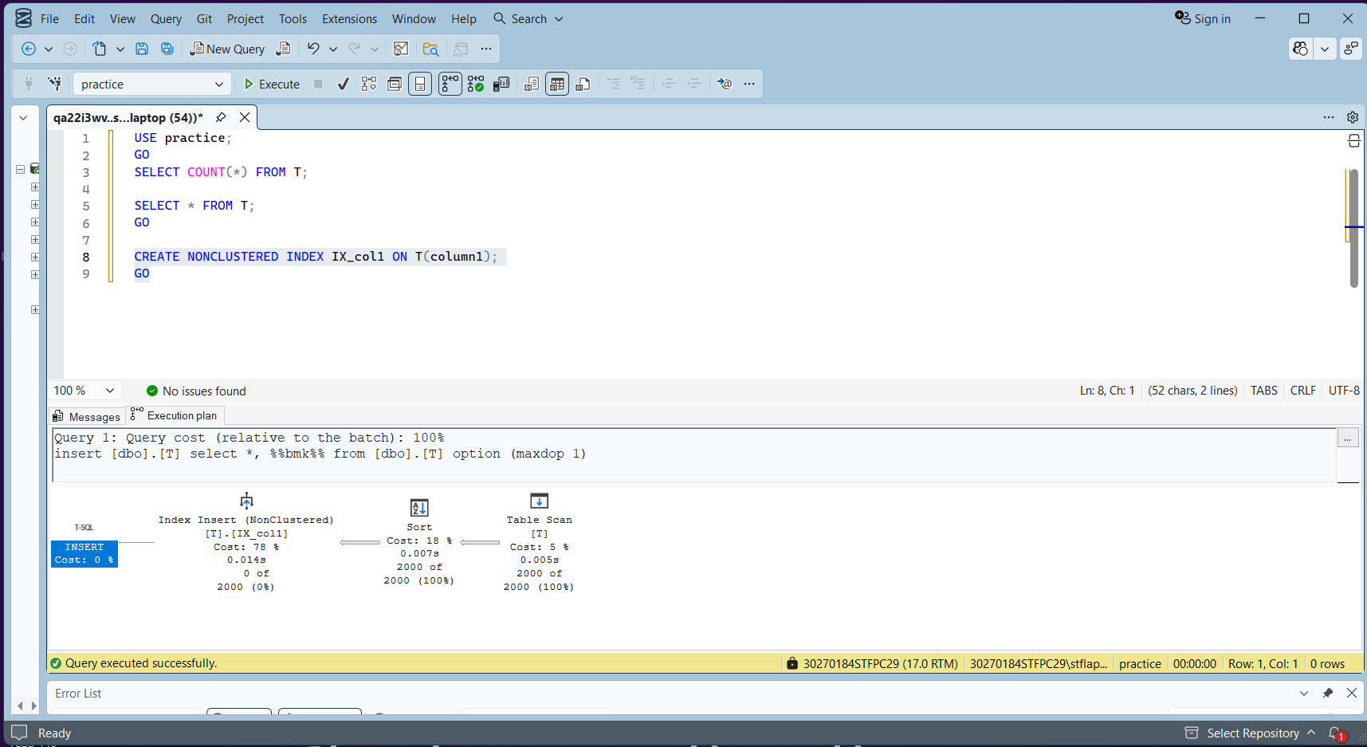

Step 5 - Non-Clustered Index Creation: CREATE NONCLUSTERED INDEX IX_col1 ON T(column1). The execution plan shows index insert cost 78%, sort cost 18%, and table scan cost 5%. SQL Server first scans the table, sorts the data, then builds the non-clustered index on column1.

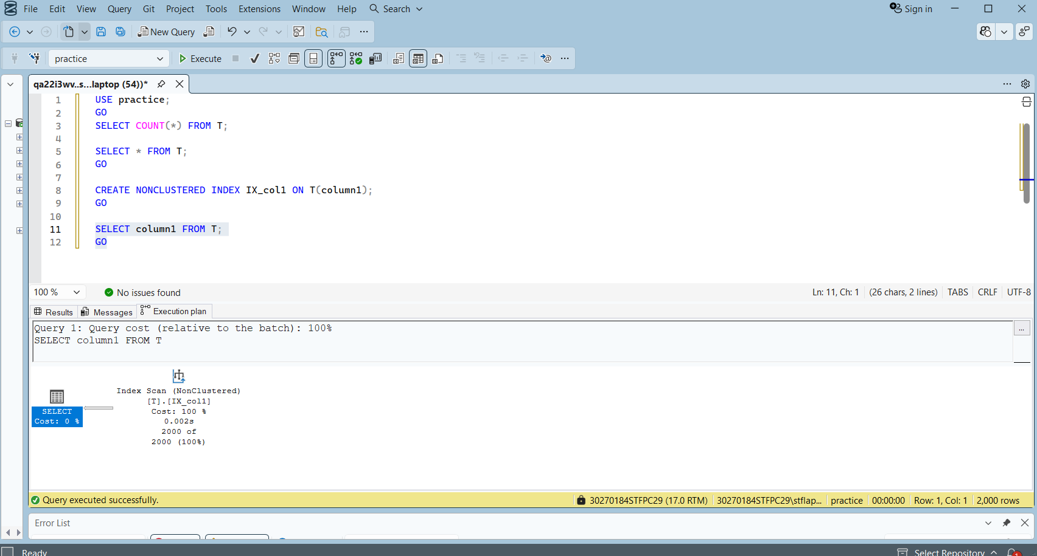

Step 5 - Non-Clustered Index Scan: SELECT column1 FROM T uses the non-clustered index IX_col1 directly. Index scan cost 100%, time 0.002s for 2000 rows. SQL Server only reads the index without touching the main table, which is faster than a full table scan.

Reflection:
From this experiment, I observed that indexes significantly impact query performance.
Table Scan: With no index, SQL Server scanned every row in the table. As the number of rows increased from 1,000 to 2,000, the scan time increased. This shows that table scans become slower as data grows.
Clustered Index Scan: After adding a primary key, SQL Server used a clustered index scan. The data is physically sorted by id, making reads more organized and efficient.
Non-Clustered Index: Creating IX_col1 on column1 required SQL Server to sort the data and build a separate index structure (shown in screenshot 14). Once built, SELECT column1 used the index scan directly (screenshot 15) without reading the main table, which was faster.
Conclusion: Yes, indexes really matter for query performance. For small tables the difference is small, but for large datasets indexes are essential to avoid slow full table scans.
------------------------------------------------------------------------------------------------------------------
Server issues during to quiz:
I experienced multiple SSMS crashes during this quiz which affected my ability to complete all runs. Below are screenshots documenting each crash with timestamps as evidence.

These crashes caused data loss and required me to restart the experiment multiple times. The timestamps on each crash screenshot confirm I was actively working within the quiz time limit.
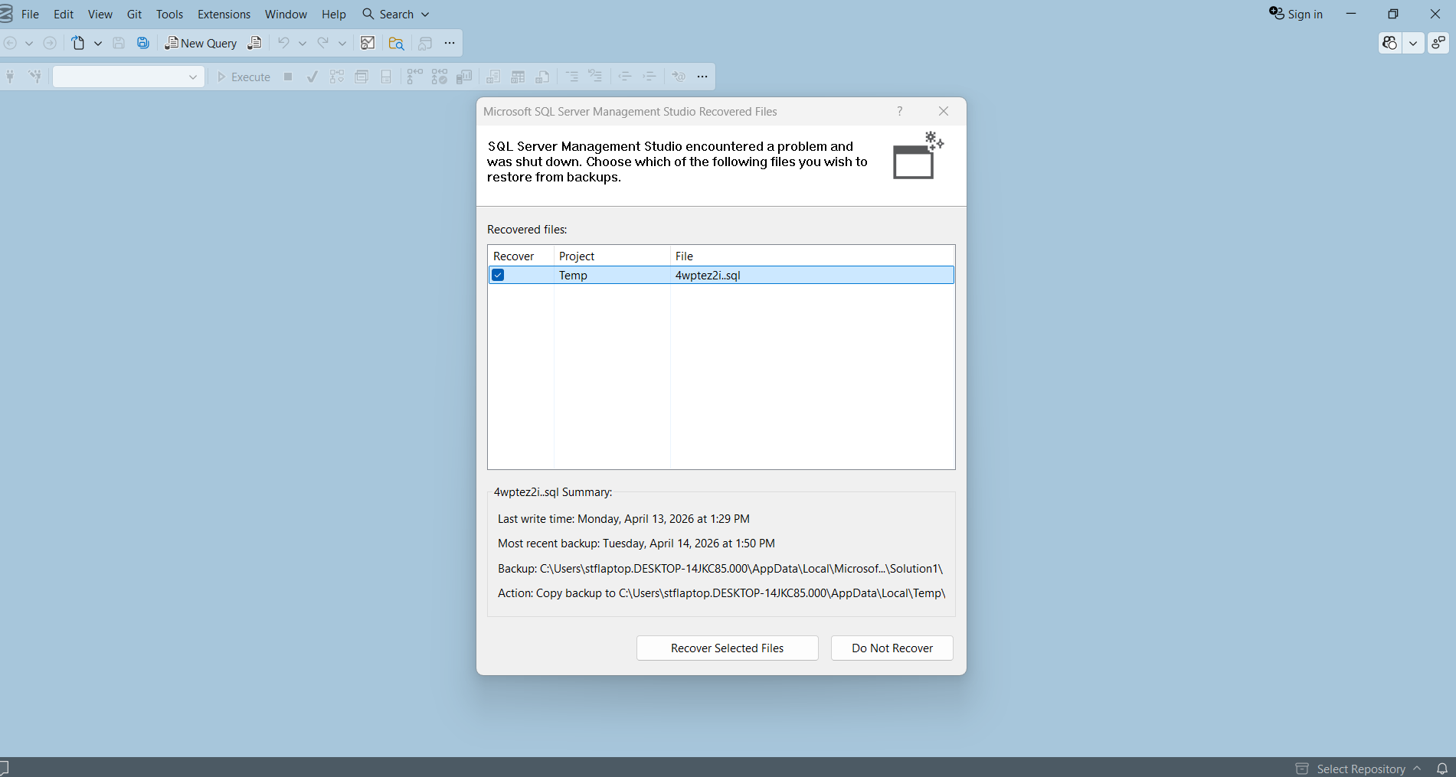
Time when it happens and I screenshot: 13:57:43pm

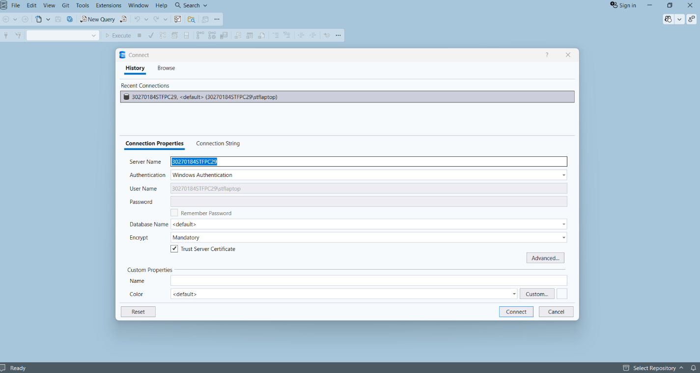
Time crash when it happens and I screenshot: 14:25:59pm

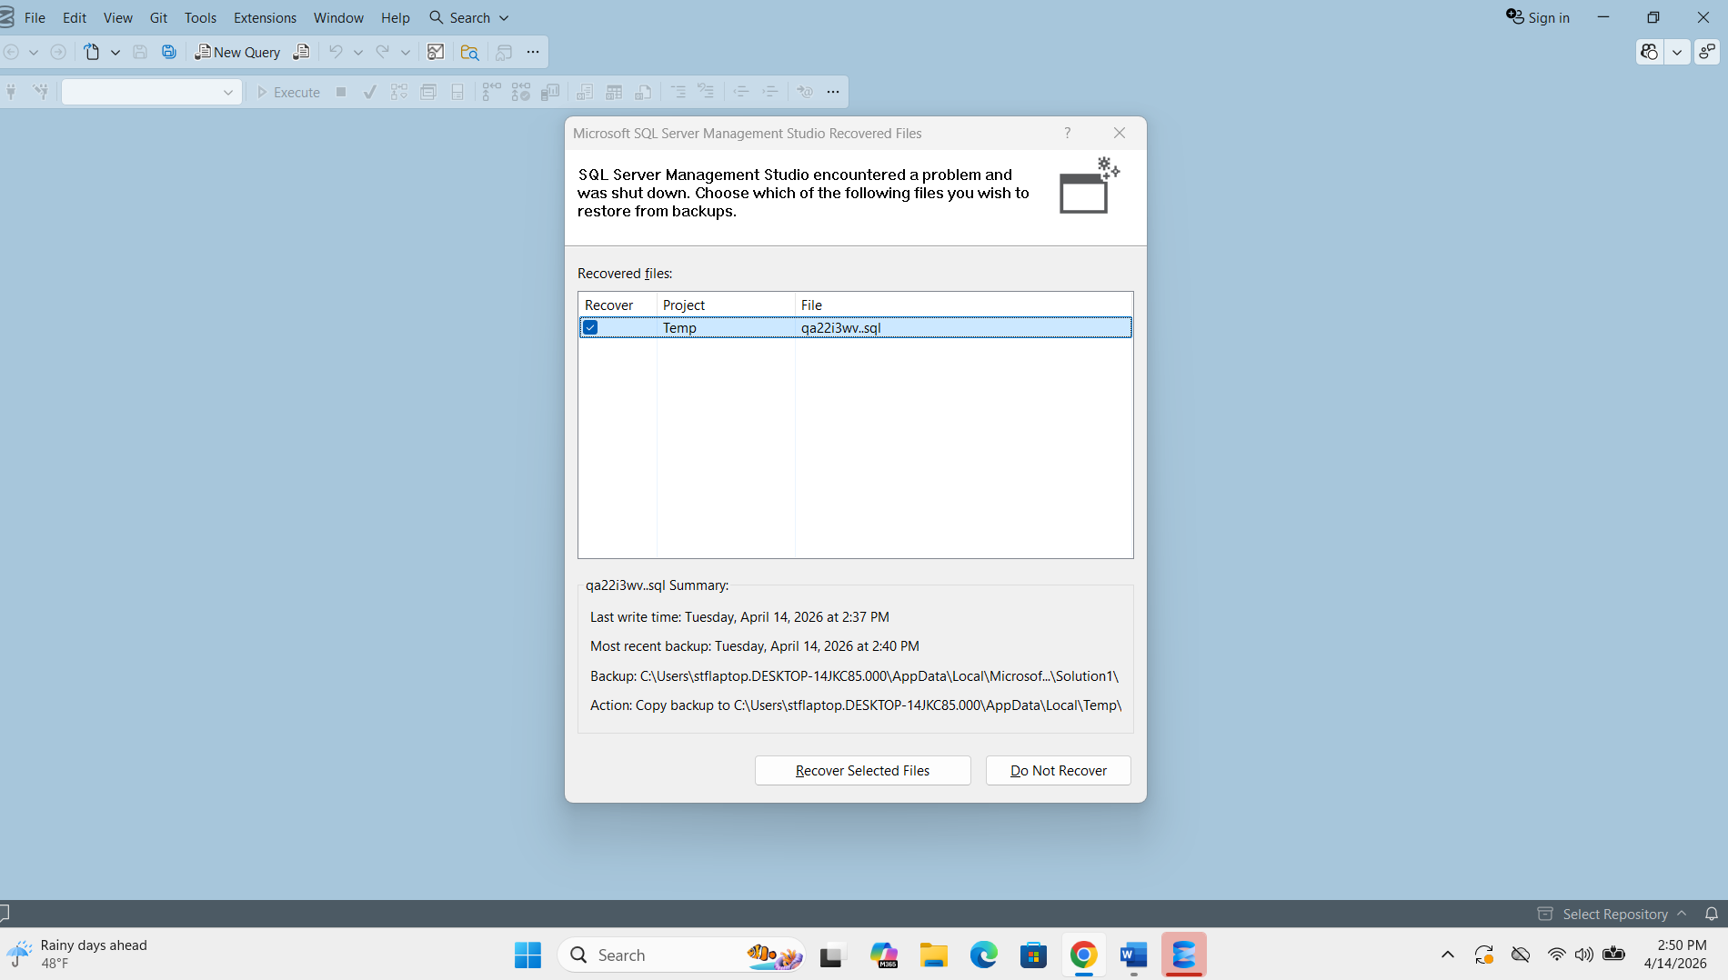
Time crash when it happens and I screenshot: 14:51:05pm
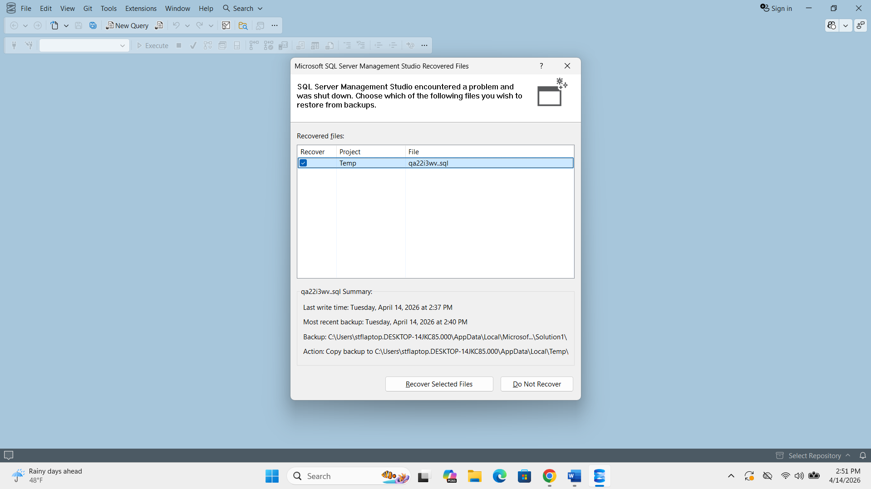
Time crash when it happens and I screenshot: 14:51:16

